**Gomoku MIPS Program User Manual**

**Table of Contents**

How to play Gomoku: Rules of the Game **1**

How to run the MIPS Program **2**

Step by Step Instructions **3**

## **How to play Gomoku: Rules of the Game**

Gomoku (Five in a Row), is an abstract strategy board game that is played using 15 x 15 grid intersections and traditionally black and white stones. Each of the two players alternate turns placing a piece of their color on an empty intersection. The winner is the first player to form a straight chain of exactly five pieces horizontally, vertically, or diagonally.

## **How to run the MIPS Program**

1. Download the [MARS simulator](http://courses.missouristate.edu/KenVollmar/MARS/download.htm) onto your computer. On the MARS download page, select the "Download MARS'' button. Additionally, download and save the zip file of the Gomoku program into a directory on your computer. Unzip it.
2. Open the MARS simulator by running/double-clicking the file you downloaded, Mars_4_5.jar
3. When the MARS simulator starts up, open the MIPS assembly file by going to the menu bar and selecting File –> Open. From there, find and click on the Gomoku program folder and select the **01-main.asm** file from the file chooser window. The file should appear under the Edit tab.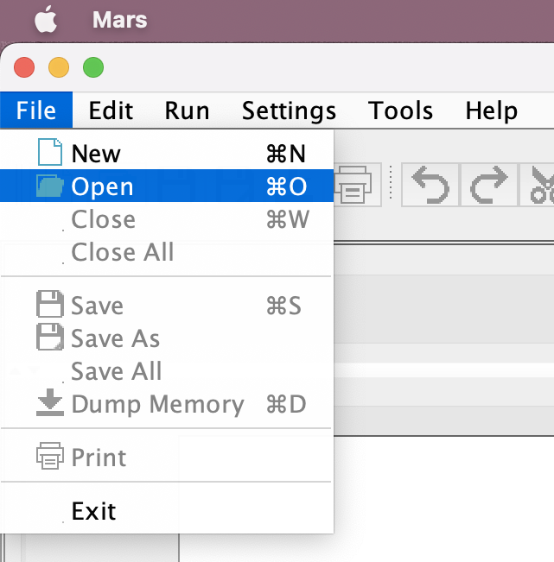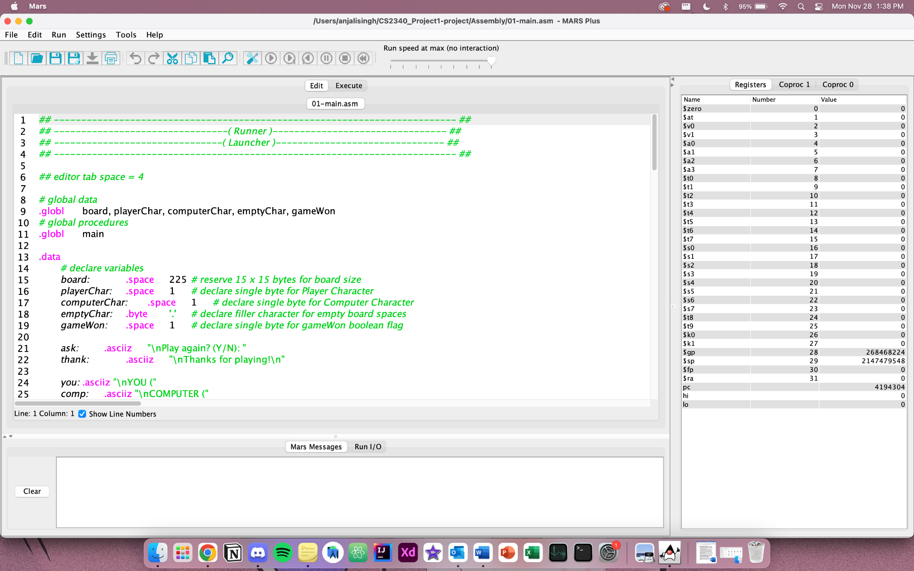
4. When ready, you may run the assembly code and start the game by first selecting Settings –> Assemble all files in directory. After that, select Run –> Assemble from the menu bar and then run the code using either the Run –> Go option, which will execute the program to completion.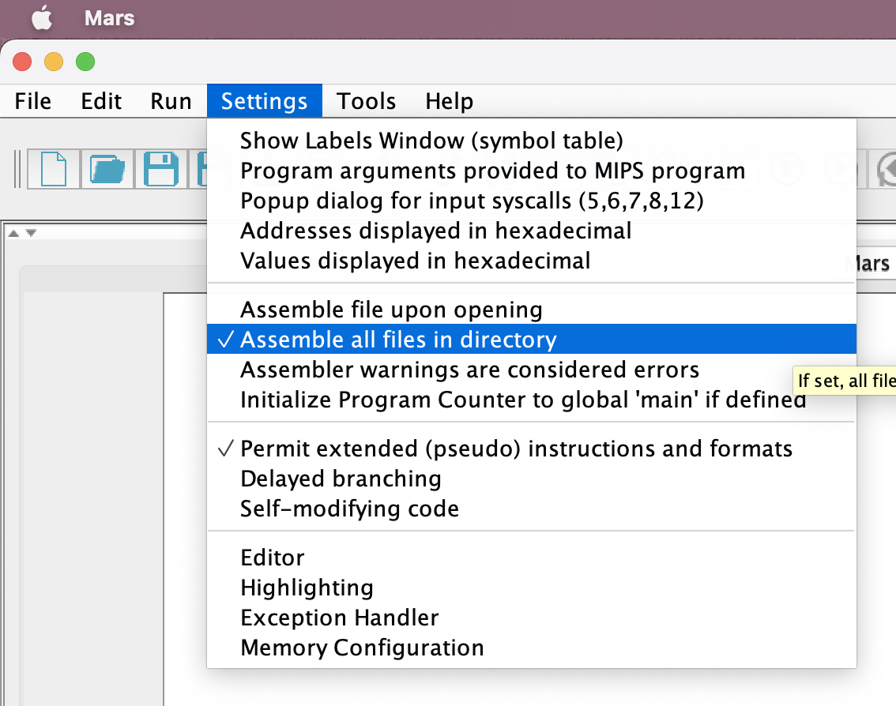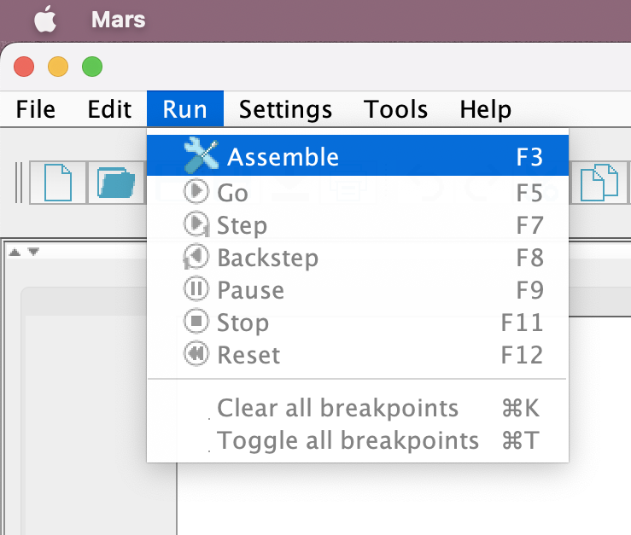

**Step by Step Instructions**

Once the program successfully runs, you will be automatically directed to the Execute tab. Down below will be the console, where under the Run I/O tab, the game starts a fresh user vs. computer game and displays the first instruction.

1. Start the game by typing your piece color X (black) or O (white) in the console 
2. When correctly inputted, a 15 x 15 board will be displayed. Moves may be entered for the desired board location by entering in an uppercase letter between A-O first, following an integer number between 1-15. (ex. A15, B2). Hit the enter or space bar when done.
   1. If an invalid movie position is entered, an error message will be displayed, outlining the rules broken. Try again and enter a valid position as the program prompts.
3. After a successful validation of the user position, the board will be updated with the recent user position and computer position, displaying their respective X and O for each player. A moves history table on the bottom of the board will be displayed and updated, keeping track of the number of moves and board position input of each player.
4. Repeat steps 2-3 until an unbroken chain of exactly five pieces in any direction is formed by either the user or the computer. Once the game is complete, either enter Y (yes) to start a new game or N (no) to exit the program